www.grizunam.net


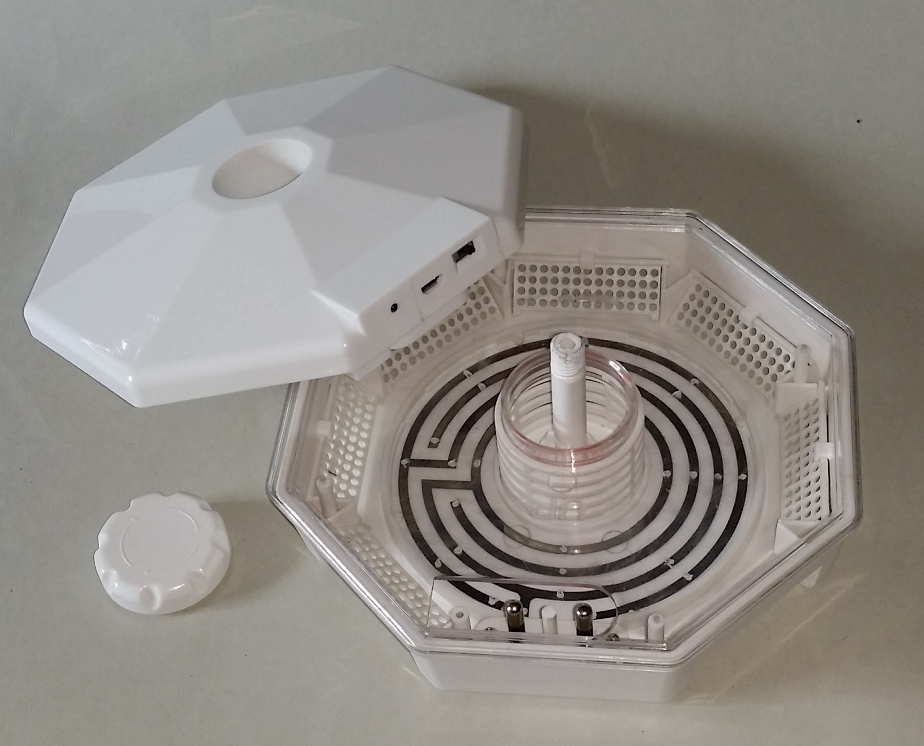



Gebrauchsanweisung Mode d’emploi
CSP CSP
Art.-Nr. 77030 Art. N°77030


Instruction for Use Gebruikshandleiding
CSP CSP
Article No. 77030 Art.-Nr. 77030

Instruction for Use
CSP
Article No. 77030

Dear Client, Congratulations for choosing one of our quality products. Please follow these instructions carefully and keep them with you.

Instructions for safe use
Important: Damage caused by not adhering to the operating instructions is not covered by guarantee. ISOTRONIC accepts no liability whatsoever for any resulting consequent damages.
- Indoor use only
- The appliance is only to be used with the power supply unit provided
with the appliance.
- Not suitable for use in barns, stables, and similar locations.
-The appliance can be used by children aged from 8 and above and
person with reduced physical, sensory or mental capabilities or lack
of experience and knowledge if they have been given supervision or
instruction concerning use of the appliance in a safe way and
understand the hazards involved.
-Children shall not play with the appliance. Cleaning and user
maintenance shall not be made by children without supervision.
-The appliance is not to be used in locations where flammable vapour or

explosive dust is likely to exist.
- Dangerous voltage
- The supply terminals are not to be short-circuited.
- Cleaning and user maintenance shall not be made by children without
supervision.
-The appliance is to be kept our of reach of children

Attention: Not suitable for use in barn, stables and similar locations. (Fire danger)
Attention: In its working condition the device
generates "high voltage".

Product description
The innovative CSP mobile from ISOTRONIC. Mobile and highly effective.The field of application for the CSP includes public buildings, restaurants, food industry operations, cafeterias and other facilities where pests and vermin are found. Consistent functionality is assured by the fine-tuned electronics. This electronic annihilator works without chemicals and does not pollute the environment in any way. Annoying pests (especially cockroaches, silverfish and sow bugs) are attracted by bait inserted in the centre of the device, e.g. dry dog/cat foot, cheese, sausage or apple pieces. On the way to the bait, the pests are annihilated quickly and hygienically by touching the electrodes, which are under high voltage that is safe for humans.

Putting into operation
1. Before putting it into operation, verify that the device exhibits no visible
damage due to transportation or similar.
2. Placing the device on the floor in a dry location is recommended. Protect the device against moisture. Remove the device before cleaning the floor.
3. Setting up the device in areas that the creatures like to frequent is
recommended (e.g. on the floor, under cabinets etc.). If possible,
use the device for prevention before entering the area being protected
in order to eliminate pests that are already present at the place of use.

LED display:
Green LED durable: The device is switched on,
high voltage is not active
Green LED flash: High voltage is active

Cleaning instructions and infestation control
Loosen the screw in the centre of the unit and remove the upper housing cover. Now the silver high-voltage electrodes in the bottom of the capture container are de-energised. Thanks to the transparent housing, you can easily check for an infestation and record it if necessary. In case of an infestation, the trap should be emptied regularly and cleaned with a soft, damp cloth. For this you can remove the transparent cover from the device. Ensure that the high-voltage electrodes (conductors) are entirely dry before using the device again. Perform this inspection regularly. When choosing the bait for the trap, make sure that no juices due to fermentation or decomposition can come into contact with the conductors. Dry food such as dog/cat food has proven itself as excellent bait for cockroaches.
Technical data
Operating modes: USB cable (included) or Mains adapter with
500 mA, (included)
High voltage: 1200 - 1500 V (3 sek. ON/3 sek. OFF)
Effective range: 40 m²
Switch: ON/OFF switch
Operating temperature and huminity: - 20C° to +50 C° and ≤ 90% R.H. Storage temperature and huminity: - 5C° to +50 C° and ≤ 90% R.H.

For indoor use only!

General information
1. Electric appliances, packaging material etc. should be kept away
from children.
2. Dispose packaging and worn out material correctly and in an
environmentally friendly way.
3. Do only pass on the device including the operation manual.
4. Subject to change of design and technical data without notice for the
sake of constant product improvement.

Warning: For environmental reasons outdoor use is prohibited because beneficial insects could be killed.

Guarantee
We grant a two year guarantee for this device. Guarantee includes repair of all defects that were not caused by defective material or fabrication mistakes. Since ISOTRONIC has no influence on correct and appropriate assemblage and operation it is obvious that guarantee applies only on completeness and proper condition. ISOTRONIC takes on neither liability nor guarantee for damages or consequential damages in connection with this product. This applies especially when the device was altered or repaired, when circuits were changed or non-original spare parts were used or when damage was caused by false or negligent operation or abuse.
Your D-78727 Oberndorf
ISOTRONIC-Team Status:12/16


Environmental protection notice
At the end of its life span this product may not be disposed as normal household waste but must be disposed of at a collecting place for recycling of electrical and electronic equipment. The icon on the product, in the manual, or on the packing points to this fact. The materials are recyclable according to their labelling. Through reusing, material recycling, or other forms of utilisation of old devices you make an important contribution to the protection of the environment. Please ask the local administration for the responsible waste disposal centre.

www.grizunam.net

